Developing Instruments to Facilitate Endoscopic Ear Surgery

Thesis Progress Report

Outline:

Literature review:

* Introduce ear surgery
* Microscopic vs. endoscopic
* Types of TEES
* Current instruments
* Needs

Objectives/ Hypotheses:

* Needs
* Developing/validating tool

Methods:

* Needs – insert paper here

# Literature Review

* Look at the karl storz/Daniele Marchione’s catalogue that he illustrated

**Endoscopic Ear Surgery:**

**Ear surgery:**

Middle ear surgery is a type of otologic surgery (ear surgery) that is done to repair the ear drum (tympanoplasty), hearing bones (ossiculoplasty) and remove tumors (cholesteatoma) that grow within the middle ear and mastoid. Traditionally, otologic surgery is performed by making a postauricular incision, as shown in Figure XXXX, to access the middle ear space and uses a microscope to visualize the surgical field. This is an invasive method of surgery and results in a scar, and longer hospital stay for the patient.

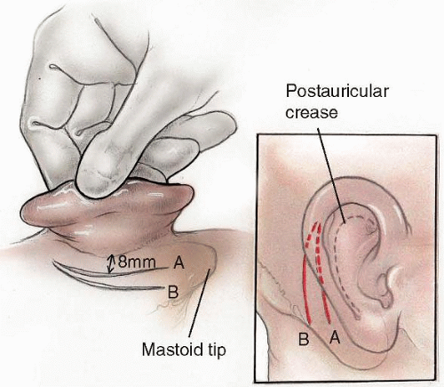

[https://entokey.com/surgery-of-the-mastoid-and-petrosa/]

Figure XXX. This image shows the slits made to access the middle ear for invasive microscopic ear surgery.

Endoscopes provide direct access and a wide angle view into the middle ear, reducing the time required to gain access, drill bone for exposure and close during middle ear surgery and are able to visualize hidden recesses within the middle ear including: the sinus tympani, anterior and posterior epitympanum and hypotympanum [1][2][3][4]. As well, the endoscope allows visualization past the shaft of the instrument, such as the drill, which is a problem during microscopic surgery[5].

**Microscopic vs. Endoscopic Ear surgery:**

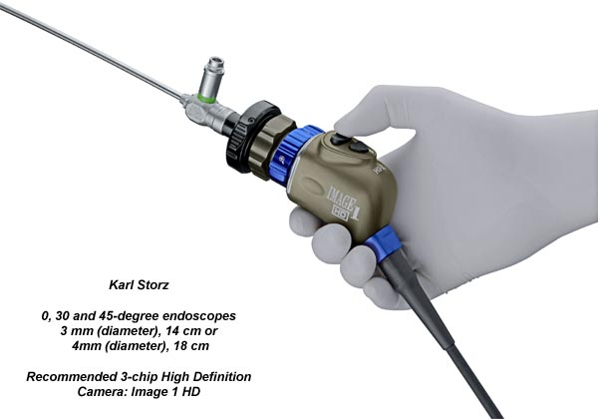

[http://www.sinuscentro.com.br/iwgees/instruments.htm]

Figure XXX. shows an endoscope that is attached to a high definition camera, which is used to visualize the surgical field during TEES.

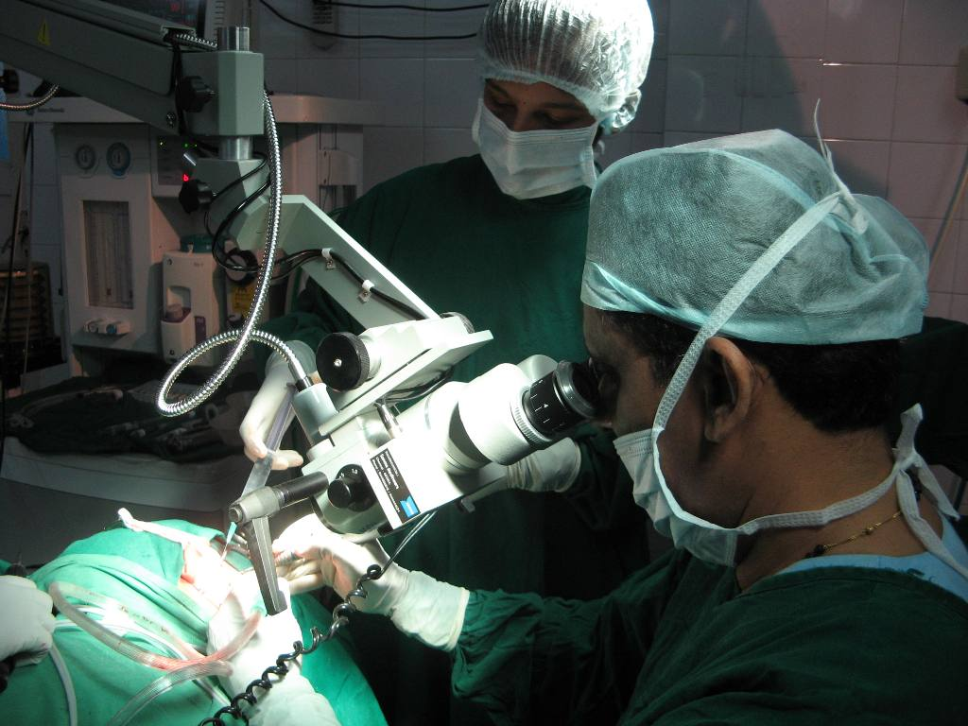 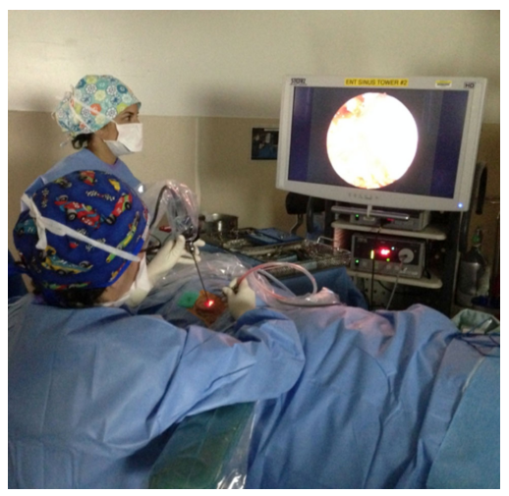

[http://drpaulose.com/ear/ent-pediatric-children/micro-ear-surgery-in-jubilee-hospital-trivandrum-keralaindia], [6]

Figure XXX shows the difference between the operating room setup for microscopic ear surgery and endoscopic ear surgery.

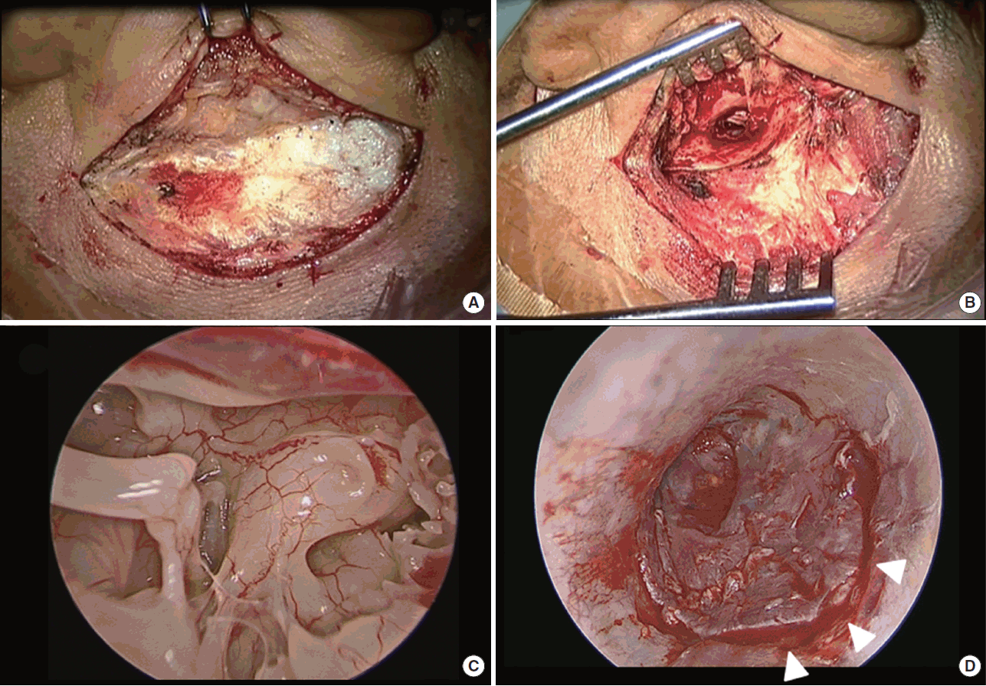 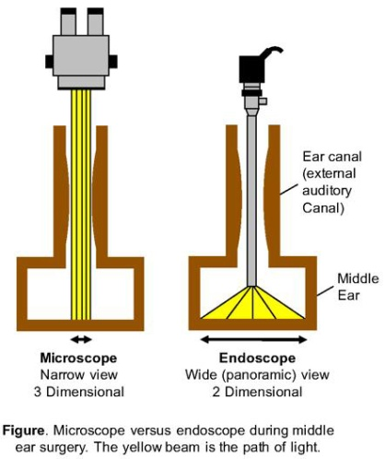

[7] Figure on the left is from Choi et al. and shows the difference in view between microscopic and endoscopic ear surgery. The figure on the right shows the difference in view between microscope and endoscope [http://entcolumbia.org/our-services/otology-neurotology/endoscopic-ear-surgery].

Despite the enthusiasm of some otologists, endoscopic ear surgery has a low adoption rate[8][9].  The principal challenge with TEES is that a one-handed surgical technique is required as the endoscope is held in the other hand[8][6]. During traditional surgery, the non-dominant hand usually maintains suction and removes blood from the operative field while the dominant hand performs the delicate maneuvers [6]. Otologic instruments were developed for two-handed microscope-guided surgery so they are not optimized for the TEES environment. As otologists have been trained and gained experience in microscope-guided ear surgery, they have developed techniques with the according instruments and have become accustomed to a two-handed surgical approach. By learning different surgical techniques and gaining experience with the endoscope, most surgeons find that they can complete more cases totally endoscopically [10][8][1][6].

Technological advances in the design of the endoscope, camera and suction dissection instruments have lead to incremental stepwise jumps in this learning curve [11]. In order to further develop technology and instruments to facilitate TEES, it is important to understand the specific challenges experienced during TEES. It is proposed that in order to facilitate TEES, the needs of surgeons and current limitations of tools must be determined.

The two types of middle ear surgery that are focused in this project are cholesteatoma removal and tympanoplasty. Cholesteatoma is an abnormal skin grown that occurs behind the ear drum (tympanic membrane) inside the middle ear and its growth can damage the ossicles and/or facial nerve and cause temporary or permanent hearing loss. TEES to remove cholesteatoma is challenging because the tumors are usually located in areas that are visible through the endoscope but inaccessible via current straight and rigid tools, thus requiring the surgeon to drill bone to access those areas with straight tools. Tympanoplasty is the reconstruction of a perforated ear drum, by placing a synthetic (animal-derived) or cartilage graft on it. It is challenging to maneuver and position the graft using TEES.

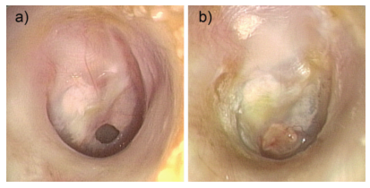

Figure XXX. These images, taken from James et al., are endoscopic photographs. (A) shows a perforated ear drum and (b) shows the postoperative result, 2 months after tympanoplasty surgery that used a cartilage graft [12].

<INSERT PICTURE OF CHOLESTEATOMA>

Managing Bleeding:

Managing bleeding has been reported as a challenge during TEES (by 24% of Canadian Otologist repondents in Lea et al.’s survey)[5][8][3][4][13]. Specialized instruments are being developed to mitigate the problem of bleeding control. Instruments that incorporate a functional tip with a suction shaft allow for cutting, dissecting or elevating tissues while suctioning[3]. As well, there are techniques to maintain hemostastis during TEES to facilitate one-handed surgery such as: injecting local anesthetic and epinephrine, packing the ear canal with topical epinephrine soaked neuro-patties before surgery, maintaining hypotensive anesthesia and gentle head elevation, careful instrument manipulation in external canal and applying epinephrine soaked cotton balls while raising the tympanomeatal flap [6][13].

### Reaching structures visualized by the endoscope and dissection and removal of cholesteatoma

Difficult to reach anatomical recesses include the sinus tympani, facial recess and anterior epitympanic recess [3]. As well, residual cholesteatoma occurs if cholesteatoma is found in inaccessible areas [14][15]. Reaching structures visualized by the endoscope and dissection and removal of cholesteatoma resulted in the highest degree of need. These two difficulties are related as dissecting and removal of cholesteatoma requires the surgeon’s tools to reach the cholesteatoma, which is often located in hard to access areas visualized by the endoscope. Specialized instruments that have a curved tip in order to reach structures visualized by the endoscope have also being developed, particularly instruments to reach the sinus tympani [3]. However, the curve in the shaft is fixed and there are areas where the tip cannot reach, which would require bone removal.

### Keeping the endoscope lens clean

Fogging and smearing of the endoscope tip is a challenge of TEES and surgeons must pause surgery, remove the fogged lens and wipe it clean on a defog pad periodically[3][13]. This difficulty during surgery requires the surgeon to remove the tool and endoscope, and wipe it periodically when the lens is not clean. The lens can also become dirty during drilling when pieces of bone and irrigation fluid are flowing in the surgical field(???).

### Moving and positioning a graft into the intended place

In tympanoplasty surgery, the approach, graft material and graft placement technique vary depending on the training, case load, resources and experience available to the surgeon [16]. During TEES tympanoplasty the graft must be inserted into the ear canal and positioned single handedly in the desired orientation, e.g. underlay technique requires the graft to be supported under the annulus anteriorly and over the neck of the malleus for anterosuperior support [16]. Performing this technique single handedly can be challenging and so perhaps a tool that facilitates graft manipulation would be helpful for TEES surgeons. Lea and Mijovic show that cartilage or graft placement is easier when using two hands in a surgery video [6]

**For Existing Tools:**

Talk about these instruments as a ‘survey’/overview of what’s already on the market

Then talk about the instruments that Dr. James uses for TEES – Panetti, Karl Storz set

Daniele used the ultrasonic bone cutting (demonstration at the TEES course in October)

David Pothier uses the standard Karl Storz ear surgery kit (no suction)

Good overview of currently existing tools for TEES: “ Ins t rumen ta tion and Technologies in Endoscopic Ear Surgery”[3]





hair trimmer

Good bone removal:

Stryker parasonic aspirator – has irrigation and aspiration but very expensive -> initial cost 100 000 + 600 disposable tips

Neuro-endoscopy instruments from Karl Storz Catalogue: *Cerebral Endoscopy for Neurocysticercosis –* Jaime G. Torres Corzo, M.D.

* Instruments are fed through a trocar, which also feeds the endoscope and the trocar is held in a stand – so the surgery set up is different from TEES
* However, the end effectors and sizes of these tools are useful for TEES – however TEES has its own Karl Storz catalogue and that has a full suite of internationally acceptable instruments that are used for ear surgery

Endoscopic Sinus Surgery: <http://www.medtronic.com/us-en/healthcare-professionals/therapies-procedures/ear-nose-throat/sinus-surgery.html>

Bausch and Lomb ENT Set: <http://www.bauschinstruments.com/pset/793/Functional-Sinus-Endoscopy-Instruments.aspx>

Karl Storz Endoscopic Catalogue: <https://www.karlstorz.com/ca/en/online-catalog.htm>

Sklar Sinus Endoscopy Set: <http://www.sklarcorp.com/instrument-sets/plastic-surgery/sinus-endoscopy-set.html>

Curved Suction:

Medtronic Fusion ENT Navigation System: <http://assets.medtronic.com/ent/flipbook-us/#p=44>

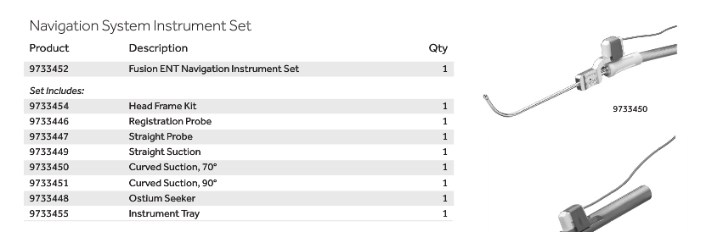

I think this has pre-curved suction (but not bendable)

<http://www.medtronic.com/us-en/healthcare-professionals/products/ear-nose-throat/image-guided-surgery/fusion-ent-navigation-system/related-navigation-products.html#supplemental>

* Frontal Suctions, 45° and 90°
* Small Straight Suction
* Suction Curettes, 45° and 90°
* Elevator
* Standard Registration Probe and Head Frame Kit (not pictured)

### **INSTRUMENT INNOVATION**

Our ENT surgical navigation instruments feature:

* Auto-recognition and seamless verification of instruments
* HeadTracker with integrated TouchPad
* Multi-instrument tracking with up to 3 instruments at once

### ORDERING INFORMATION

[View our ENT Product Catalog](http://assets.medtronic.com/ent/flipbook-us/) or call your local ENT representative to learn more.

*Note: These surgical navigation instruments are only available as sets in the US. If you are outside the US, items in sets must be ordered individually.*

### [NUVENT EM BALLOON SINUS DILATION](http://www.medtronic.com/us-en/healthcare-professionals/products/ear-nose-throat/image-guided-surgery/fusion-ent-navigation-system/related-navigation-products.html)

### [MALLEABLE SUCTIONS](http://www.medtronic.com/us-en/healthcare-professionals/products/ear-nose-throat/image-guided-surgery/fusion-ent-navigation-system/related-navigation-products.html)

### [EM TRACKING BLADES](http://www.medtronic.com/us-en/healthcare-professionals/products/ear-nose-throat/image-guided-surgery/fusion-ent-navigation-system/related-navigation-products.html)

### [PATIENT TRACKING](http://www.medtronic.com/us-en/healthcare-professionals/products/ear-nose-throat/image-guided-surgery/fusion-ent-navigation-system/related-navigation-products.html)

### [STEALTHMERGE AND DICOM Q/R](http://www.medtronic.com/us-en/healthcare-professionals/products/ear-nose-throat/image-guided-surgery/fusion-ent-navigation-system/related-navigation-products.html)

### [STEALTHSTATION](http://www.medtronic.com/us-en/healthcare-professionals/products/ear-nose-throat/image-guided-surgery/fusion-ent-navigation-system/related-navigation-products.html)

#### RELATED LINKS

* [Overview](http://www.medtronic.com/us-en/healthcare-professionals/products/ear-nose-throat/image-guided-surgery/fusion-ent-navigation-system.html)
* [Related Powered Surgery Products](http://www.medtronic.com/us-en/healthcare-professionals/products/ear-nose-throat/image-guided-surgery/fusion-ent-navigation-system/related-powered-surgery-products.html)
* [Procedures and Techniques](http://www.medtronic.com/us-en/healthcare-professionals/products/ear-nose-throat/image-guided-surgery/fusion-ent-navigation-system/procedures-techniques.html)
* [Coverage and Reimbursement](http://www.medtronic.com/us-en/healthcare-professionals/products/ear-nose-throat/image-guided-surgery/fusion-ent-navigation-system/coverage-reimbursement.html)
* [Customer Services](http://www.medtronic.com/us-en/healthcare-professionals/products/ear-nose-throat/image-guided-surgery/fusion-ent-navigation-system/customer-services.html)

#### RELATED PROCEDURES

* [Sinus Surgery and Transnasal Skull Base Surgery](http://www.medtronic.com/us-en/healthcare-professionals/therapies-procedures/ear-nose-throat/sinus-surgery.html)
* [Otology, Neurotology, and Lateral Skull Base Surgery](http://www.medtronic.com/us-en/healthcare-professionals/therapies-procedures/ear-nose-throat/otology-neurotology-lateral-skull-base-surgery.html)
* [Cranial Surgery](http://www.medtronic.com/us-en/healthcare-professionals/therapies-procedures/neurological/cranial-surgery.html)

## ENT PRODUCT CATALOG

Medtronic offers more than 5000 products and instruments for ENT specialists.

[VIEW](http://assets.medtronic.com/ent/flipbook-us/)

## MEDTRONIC ENT

Quick access to ENT products, therapies, reimbursement, and other resources.

[MORE](http://www.medtronic.com/for-healthcare-professionals/business-unit-landing-Page/ent/index.htm)

#### CONTACT MEDTRONIC ENT

[(800) 874-5797](tel:8008745797)

[(904) 296-9600](tel:9042969600)

Patent:

https://www.google.com/patents/US9226800

Steerable Instruments:

Existing adjustable flexible tool: adjustable laser probe for vitreoretinal surgery <https://patents.google.com/patent/US7766904B2/en?q=endoprobe&q=adjustable&q=flexible>

* Slider at handle allows surgeon to retract the sheath which leaves behind the flexible nitinol prebent to 90deg.
* Finger must stay in place to keep the bend



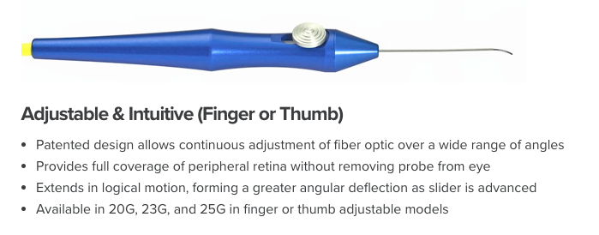 <http://salientmed.com/solution/endoprobe-handpieces/>

Manually engageable handle + steerable tip:

<https://www.google.com/patents/US5454827>

* Pin joints in the tip



“A Novel Design for Steerable Instruments Based on Laser-Cut Nitinol”

* Surgeon’s hand controls the proximal end that translates into movement at the distal end

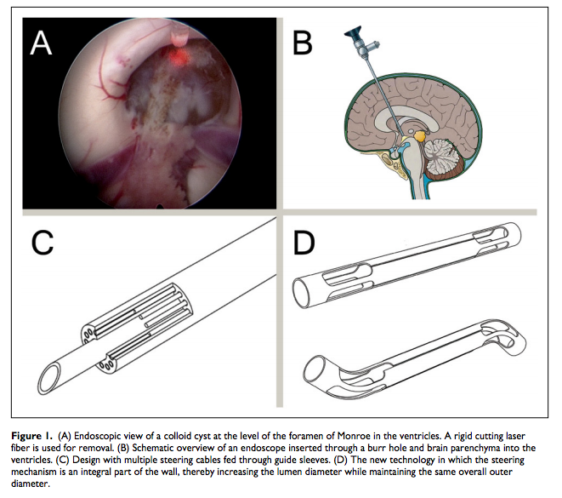

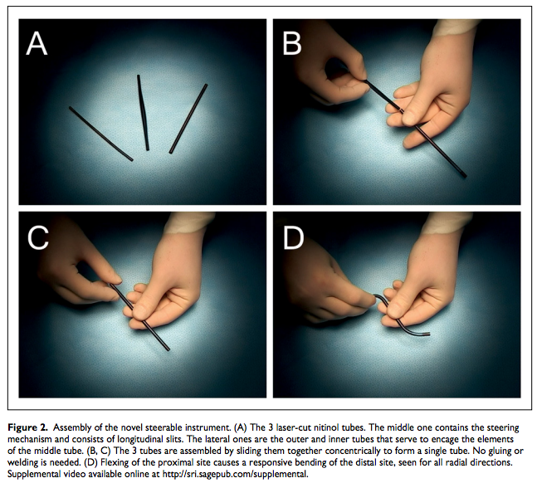

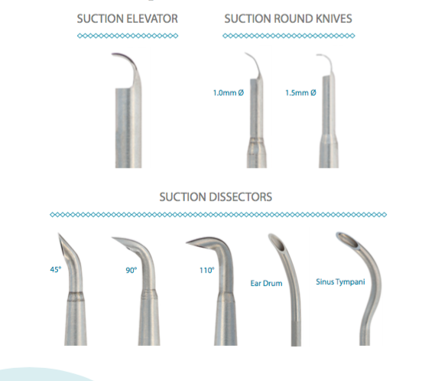

Grace Medical IWGEES Instruments

Stryker ultrasonic aspirator

Piezosurgery

* Overview of existing tools from “Instrumentation and Technologies in Endoscopic Ear Surgery”

**For Testing Tools:**

* “Development of Tasks and Evaluation of a Prototype Forceps for NOTES”
  + this paper outlines a testing protocol to compare a standard instrument and prototype (forceps and cutting instrument) – it compares them using 6 tasks developed from a standard and literature
    - outlines these tasks by describing pictures
  + included comments made by surgeons while using the tool and the frequency of the comments e.g. “this tool is helpful” was said x number of times
* “A novel laryngoscope instrument stabilizer for operative microlaryngoscopy”
  + tested a stabilizer with surgeons and asked them to fill out a survey afterwards
  + results of the survey are just listed (no graph)
    - Physicians also rated instrument stability, mobility, visualization, and ease of use on a survey form. RESULTS:
      * Instrument stability was highly rated (mean score 8.8). Target visualization was felt to be somewhat impaired (mean score 6.2), and instrument mobility was also rated low (mean score 5.0). Overall utility of the instrument was rated a mean 8.7 by the 17 evaluators. All but 1 eval- uator indicated that they thought that the instrument would be useful for them in laryngeal microsurgery
* “Robot-assisted laparoscopic ultrasonography for hepatic surgery”
  + Questionnaire. All 10 subjects completed the questionnaire after the US task experiments. All subjects had extensive laparoscopic experience (>30 cases) and 40% of subjects had moderate experience (>15 cases) with laparoscopic US. The RLUS was noted by the majority of subjects to be associated with better positioning (8/10), more comfortable (6/10), greater confidence in lesion finding (8/10), less fatigue inducing (9/10), and an overall more useful tool (9/10). – this was just reported (no graph or table)
  + Tasks were performed by handheld tool and robotic tool and the surgeon gave a score for factors during each task and the scores were compared between robot and handheld tool, then t-test between the two scores to see if there is a significant difference – presented in table format

# Objectives/Hypotheses

The aim of this project is to develop and evaluate surgical instrumentation for minimally invasive transcanal endoscopic ear surgery (TEES), which enables patients to go home same day. TEES requires a one-handed surgical technique as the endoscope is held by the other hand, which is very challenging for surgeons. Current instruments have been designed for the two-handed traditional microscopic invasive surgical technique. This project aims to design and evaluate a new instrument that would address the challenges faced by endoscopic ear surgeons.

We hypothesize that otologists need better instrumentation to facilitate specific challenges posed by TEES. Further, we hypothesize that otologists performing greater proportions of surgeries using TEES will experience different challenges than those who use TEES less frequently. Similarly, we hypothesize that those surgeons who use specialized TEES instrument sets may experience different challenges that those who do not. To this end, we conducted a mixed-methods study to explore these hypotheses.

## Phase 1: Understanding the Needs of Endoscopic Ear Surgeons and conducting a Time Flow Study:

An online needs analysis questionnaire was sent to endoscopic ear surgeons internationally. Surgeons were asked to indicate their TEES experience, their need for a new instrument to facilitate eight different challenges experienced during TEES and comment on what new instrumentation they would like to see developed. Thus far, 51 surgeons have responded and the surgical difficulty of “reaching structures visualized by the endoscope” scored the highest average of 83% ± 4% need for new instrumentation. A Kruskal Wallis test with a 95% confidence interval showed that participants who perform more than 50% of surgeries totally endoscopically had a significantly greater degree of need for reaching structures visualized by the endoscope, positioning an ear drum graft and dissecting cholesteatoma. A clinical research paper has been drafted and will be submitted to an otolaryngological clinical journal. As well, a time flow study, where the durations of surgical steps were recorded during TEES was conducted. The goal of this study is to measure the efficiency of surgical steps and count the number of instruments used to facilitate the step. This will help us understand what steps require better instrumentation and what functionalities new instruments should exhibit. So far, out of 12 surgeries, dissecting the skin off of the ear canal to access the middle ear space has the greatest median time of 23 minutes. This study will also be submitted to an otolaryngological clinical journal. The studies in Phase 1 underwent scientific review and REB review and were approved in March, 2017.

**Phase 2: Development and Presentation of a Prototype Instrument:** A prototype (shown below) was manufactured at the lab using Solidworks, 3D printing, a micro-milling machine and assembly of components purchased from McMaster Carr. This instrument has a flexible tip that can bend in one degree of freedom, controlled by the black “thumb piece”. This prototype was presented at the 2nd World Congress of Endoscopic Ear Surgery in Bologna, Italy on April 29, 2017. From the conference, we gathered feedback on how to improve upon the tool.

**Phase 3: Refining the Prototype Using Patient Anatomical Data:** Future work includes refining the prototype so the tip bend into a curvature whose parameters are appropriate for accessing patient anatomy. The PI has provided several patient CT scans whose anatomy were challenging for TEES; they have been segmented into 3D models, onto which a CAD of the tool is integrated and the appropriate arc length and radius of curvature of the tool will be determined. Use of the CT scans has SickKids REB approval. We aim to present the refined tool at Sentac, a pediatric otolaryngology conference where an abstract has been submitted.

**Phase 4: Validation of the Tool:** 3D printed temporal bone models will be given to TEES surgeons with the final prototype to assess the effectiveness and feel of the tool. The effectiveness will be measured by determining whether or not the tip can reach the intended areas within the anatomy using the endoscope and feel will be ranked using a survey. An REB application has been submitted to conduct this study.

# Methods

From the needs analysis study, developing a controllable flexible instrument that can reach areas visualized by the endoscope would be addressing the greatest difficulty for TEES surgeons.

Requirements:

These requirements will be used to evaluate the tool and if it is appropriate to meet the functional requirements as well as be used during TEES

|  |  |  |  |  |
| --- | --- | --- | --- | --- |
| Requirements: | Metric: |  |  |  |
| Functional Requirements: | | | | |
| Reach areas visualized by the endoscope | PASS/FAIL |  |  |  |
| Reach hard-to-reach areas such as the sinus tympani, boundaries of the antrum | PASS/FAIL |  |  |  |
| Tip stiffness |  |  |  |  |
| Tip reachability |  |  |  |  |
| User Requirements (Criteria): | | | | |
| Easy to control (grip and ergonomics of handle) | Surgeon feedback (rating) |  |  |  |
| Easy to use (grip and ergonomics of handle) | Surgeon feedback (rating) |  |  |  |
| Feels like an existing tool |  |  |  |  |
| Constraints: | | | | |
| Fit alongside the endoscope | PASS/FAIL |  |  |  |
| Fit inside the ear canal |  |  |  |  |
| Sterilizability |  |  |  |  |

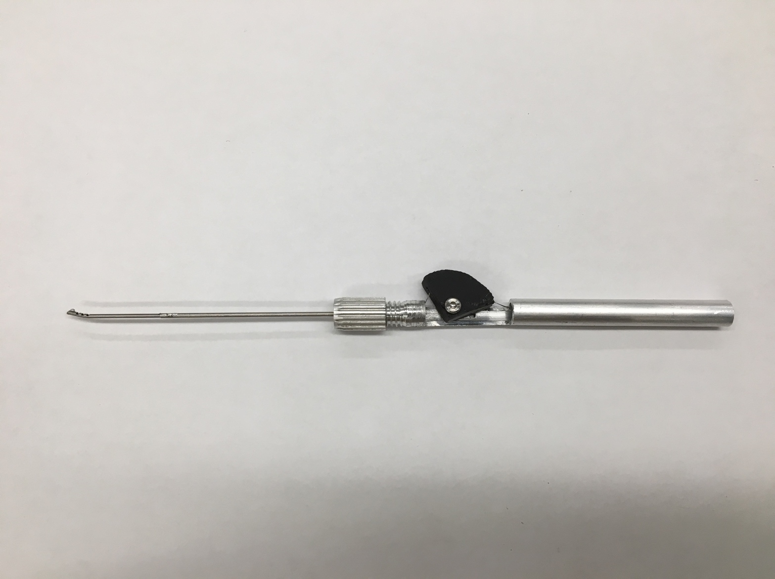

Finger piece

Steerable tip

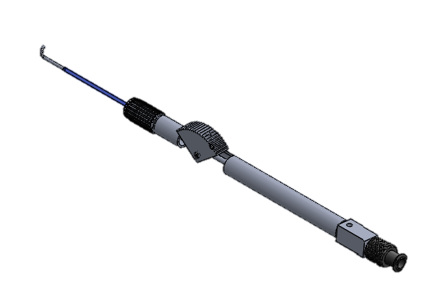

Luer Lock

Finger piece

Steerable tip

Figure XXX. shows the version 1 prototype of the controllable flexible instrument.

Reaching sinus tympani:

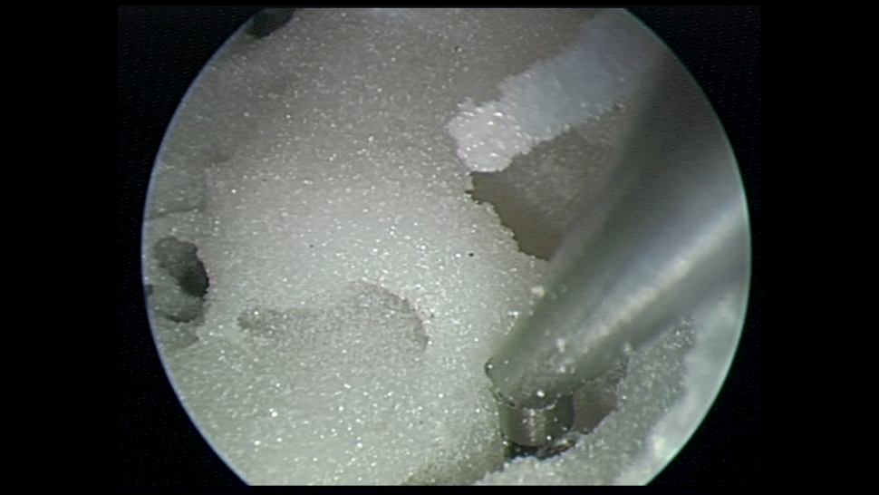

Promontory

Sinus Tympani

Dissecting the tegmen:

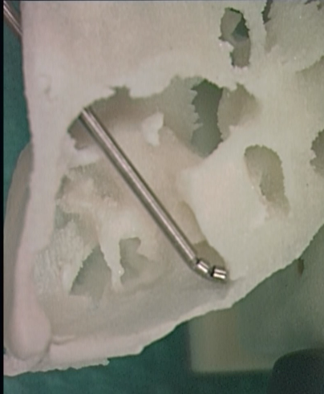

Manufacturing Prototype 1:

The wrist was manufactured using a CNC MicroMilling Machine <machine spec/description> to cut notches in a nitinol tube, OD = 1.24mm, ID = 1.03mm. This tube was chosen as its ID is greater than the ID of a 19 gauge sucker, which is the smallest diameter sucker that has enough suction power. A simple initial rectangular notch pattern was milled as a first test prototype. The nitinol wrist was soldered to a stainless steel shaft that is clamped in a collet, using a collet clamp, at the distal end of the handle. The handle was machined so the collet clamp can be threaded onto the distal end and there is room for the finger piece to rotate. The cable, soldered to the tip of the wrist, runs along the tube and is clamped in the finger piece.

Manufacturing Prototype 2:

After testing the initial prototype, the next step is to finalize the design of the wrist such that it will reach the areas of interest within the middle ear during TEES. A simple experiment was conducted to narrow down the arc length of the wrist required to reach difficult to reach areas within the middle ear. Fichera et al. described the process they used to create a steerable endoscope which is < 2mm in diameter with a notched nitinol tube wrist with an HD camera mounted on the tip [17]. They designed this to inspect the middle ear space by going through the Eustachian tube accessed through the nose [17]. In order to determine the appropriate parameters of the steerable tool: endoscope diameter, length, required curvature, they generated 3D models of patient middle ear space by CT scan image segmentation. On these models, target points where the endoscope needed to reach were identified and the optimal path to reach the target was computed using a computer software developed by the research group. These paths identified to reach the target maximized visual coverage of the sinus tympani (area where cholesteatoma generally recurs), calculated the associated bending angle and arc length – calculation shown in reference [2] of the paper. They used a nitinol tube which is larger than the proposed tool (OD = 1.8mm, ID = 1.6mm) which validates that this tube size will fit inside the middle ear space.

* sinus tympani anatomy: D. Marchioni, S. Valerini, F. Mattioli, M. Alicandri-Ciufelli, and L. Presutti, “Radiological assessment of the sinus tympani: Temporal bone HRCT analyses and surgically related findings,” Surg. Radiol. Anatomy, vol. 37, no. 4, pp. 385–392, 2015.

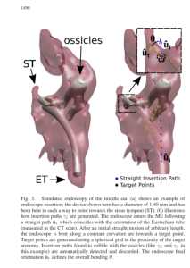

* From 6 high res CT scans

To determine the approximate, appropriate range of motion for the proposed tool to reach in difficult to reach areas within the middle ear during TEES, a simplified, modified approach, inspired by the Fichera et al. study was used. The range of arc length and radius of curvature needed to be identified. The PI provided 9 CT scans from patients with with difficult TEES anatomy where bone had to be removed to access the cholesteatoma to remove it. The CT scans were segmented using Materialise Mimics and 3-Matic image segmentation software. 3D models of the patients’ temporal bone were rendered and within these, specific anatomy: the sinus tympani and antrum were identified, see Figure XXX.

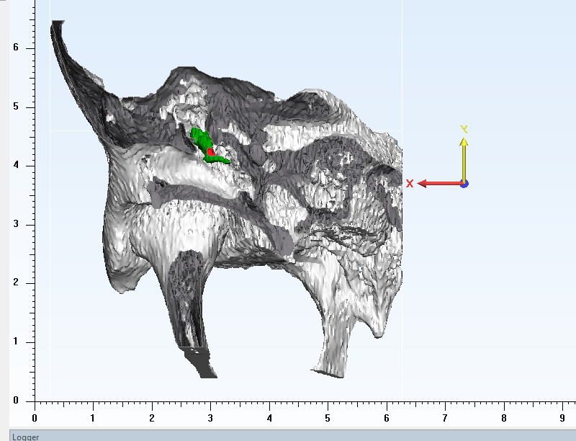

Antrum

Ossicles

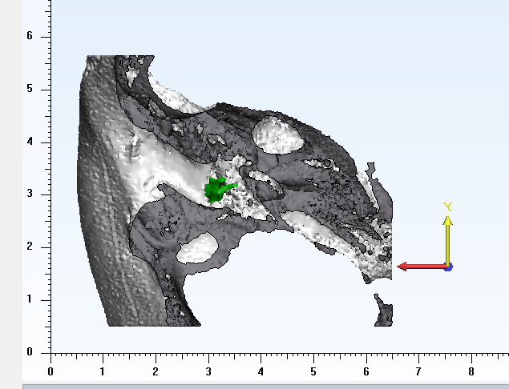

Sinus tympani

Ossicles

The next step was to determine the range of arc lengths for the new tools. The radius of curvature is bound by the outer radius of the tube: minimum radius of curvature = 2*outer diameter of tube. Based on this, a sketch of the range of articulation for the tool from minimum radius of curvature to straight was rendered for different arc lengths. These were printed in 2D and overlaid to determine the appropriate arc lengths to reach the targets. A smaller arc length yields a stiffer tip, which is desirable for dissection and better control of the instrument.

|  |  |  |
| --- | --- | --- |
|  | **Radius of Curvature (Rc)** | **Arc Length (s)** |
| Min | Rcmin = 2*Ro = **1.24mm**  Smin = minimum arc length  Ro = outer radius of NiTi tube | S = rθ  S = 1.24*3pi/4 = **2.92mm**  To achieve bending angle = 135deg. To reach the boundary of the 0deg endoscope field of view |
| Max | S=Rc*θ  Rc = s/θ = 7.5/(3*pi/4) = **3.18mm** | **7.5mm**: distance between promontory (bony boundary of middle ear) and tympanic spine* |

Dahm et al. reported the anatomical measurements on 60 cadaver specimens, and reported that the average distance between the promontory and tympanic spine is 7.48mm for all specimens and this distance doesn’t change with age [18]. This describes the maximum arc length that is limited by the anatomy of the middle ear as this is the distance between the endoscope at the medial end of the ear canal where the middle ear begins and the promontory which is the boney wall of the middle ear (???). Using Matlab, a randomly distributed of 10 arc lengths was generated to span the range 2.92-7.5mm and these were used to generate a 2D sketch of the workspace/reaching area of a wrist with that arc length sweeping from radius of curvature 1.24 mm to straight. These were superimposed on the cross sections of the 3D models to select the parameters for the next prototypes.



<https://image.slidesharecdn.com/2-151023145818-lva1-app6892/95/anatomy-of-middle-ear-4-638.jpg?cb=1445612510>

Timeline

Bibliography